How to Reset or Change an Employee Password

Locate and open the employee record using the employee search. Click the employee name in the search results to open their record.
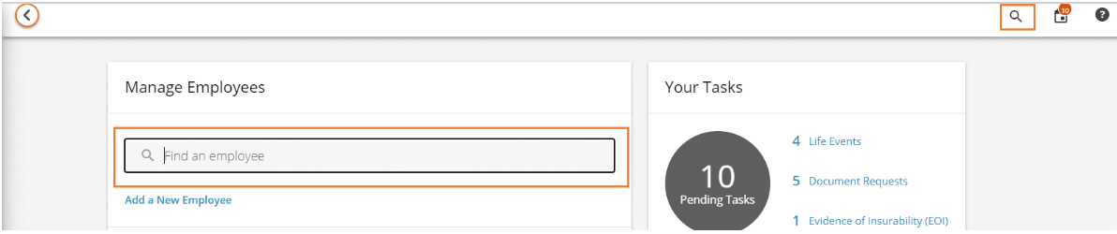

Click Actions then select Change Password.
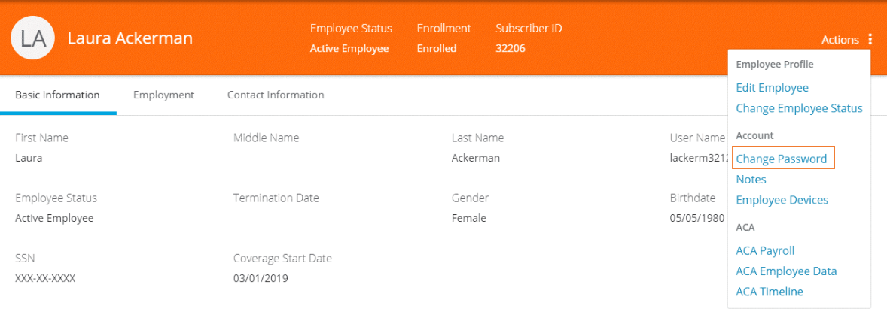

The Change Password window displays.

- To change password, enter the new password and confirm it, then click Save.
  - If there is no email on file for the employee, a warning displays at the top of the employee record, indicating the password has not been sent in an email to the employee. The administrator must communicate the new password to the employee some other way.

- To reset password, select Send Reset Password Email (Note: This option will not display unless there is an email address on file for the employee)
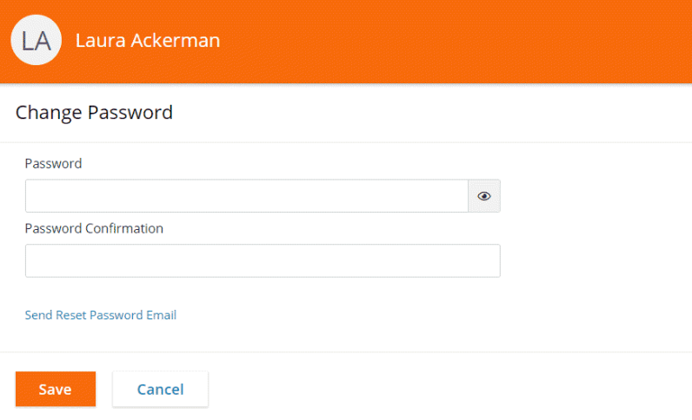

The employee will receive an email containing their new password which is their date of birth, in the format YYYYMMDD.
Employees also have the option to use the Forgot Password link on the login screen to reset their password.

How to Reset MFA for an Employee

Locate and open the employee record using the employee search. Click the employee name in the search results to open their record.

Click Actions then select Reset MFA.
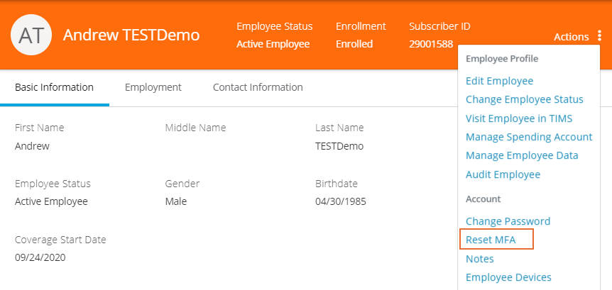

Click Confirm to reset MFA.
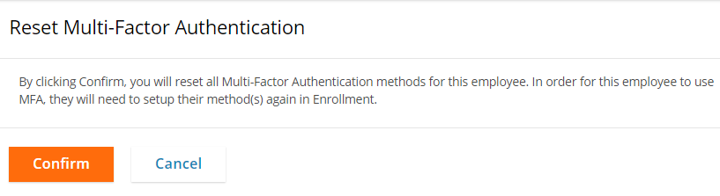

After the MFA has been reset for the employee, they will be prompted to re-enter their cell phone number when they go to log in again.

