Administrative override is a Life Event option available to administrators only. It allows for open access to make any change to an employee’s benefit enrollment without a specified timeframe. It’s very important to understand how this event may affect all aspects of the enrollment. For example, if an update is made to a benefit outside of a 30 day window, confirm it will feed and be accepted by the carrier.

- Log into the portal as an HR Admin
- Use the Find an Employee option to search for the employee
- Click the Actions menu in the Tasks section of the Employee profile
- Select Create a Life Event
7. You are then prompted to review the employee’s profile, dependents, and benefit elections. Click View or Change Plan next to the benefit plan that needs updating. When finished, make sure to Checkout in order for changes to be saved.

*** Remember to go back to the Admin Home Page when your enrollment is complete. Select the life event you just processed under Tasks to accept the changes you have made. If you do not Accept/Reject the Life Event, it will remain open and the employee will be able to make updates.
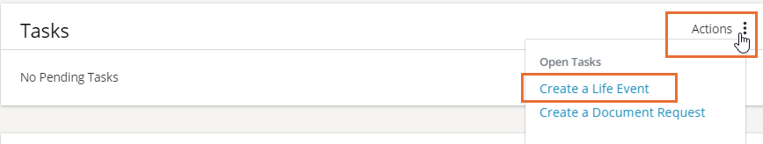
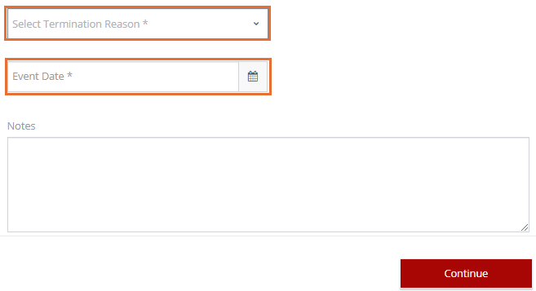

5. Scroll to the last Life Event option and select Administrative override.
6. Select a Termination Reason from the drop-down and enter the Event Date. Add any necessary notes and click Continue.

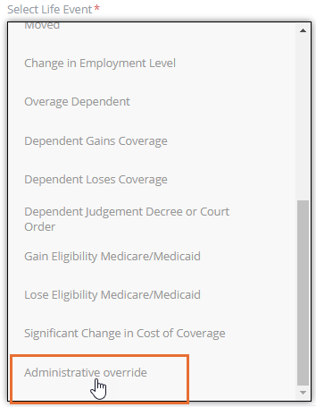
5. Scroll to the last Life Event option and select Administrative override. Enter the Event Date (effective date of the Life Event). Add any necessary notes and click Continue.

